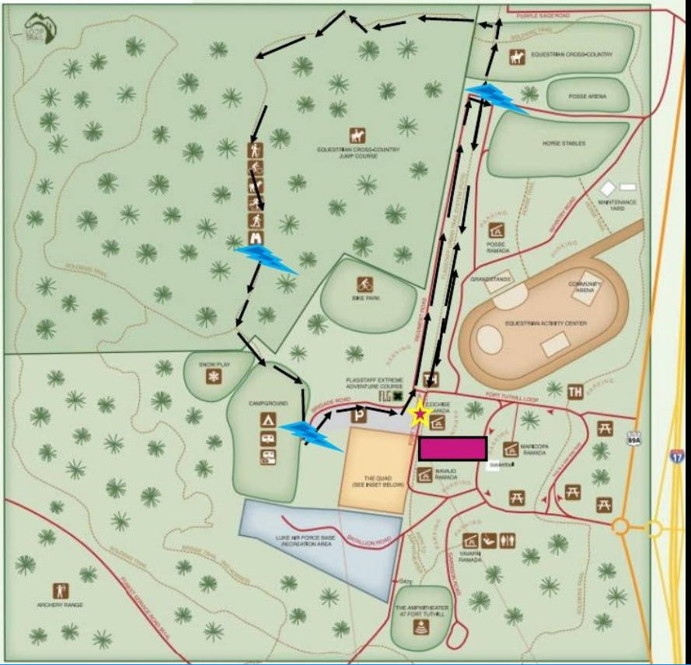
Net Control
XX
Follow the X to the Adventure Center
You’ll see the start to your right.
Water station 3
water stations 1
water 111station
Water station 2
Girls on the Run Ft Tuthill 2016 Nov 12
3 Hill
The race starts at 10:00, try to be at the start by 9:00 so we can be at our stations by 9:30
Frequency Mt Elden Repeater 146.980

Net Control Pat and Al KE7QFG & KF7HSD
Water Station 1 Bob M KF4RKS
Hill Sandy KF4JHC
Water Station 2 Ken KF7DUR
Water Station 3 Phil and Bobbi AE7OH & W6HQJ

